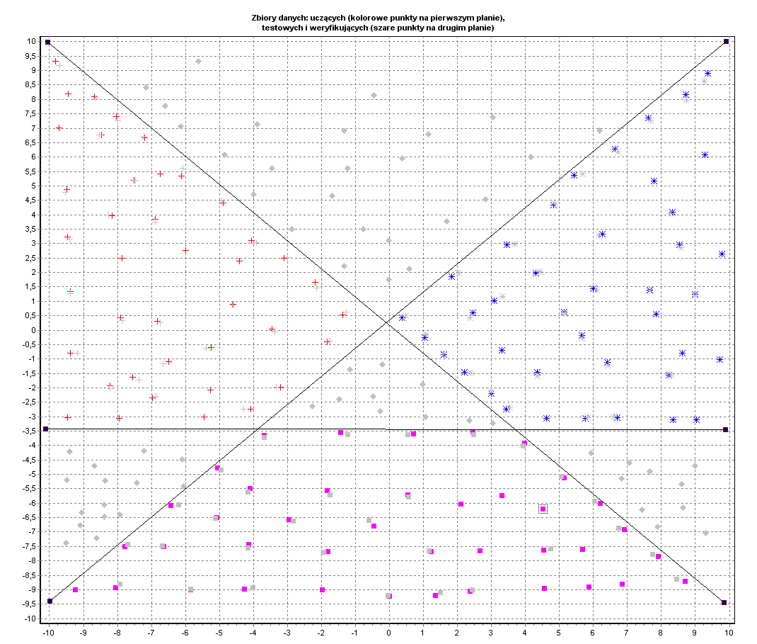
DANE UCZĄCE:

1 | -9,822 | 9,322 | Klasa 1
2 | -8,678 | 8,094 | Klasa 1
3 | -7,200 | 6,669 | Klasa 1
4 | -6,118 | 5,343 | Klasa 1
5 | -4,890 | 4,409 | Klasa 1
6 | -4,058 | 3,107 | Klasa 1
7 | -3,101 | 2,493 | Klasa 1
8 | -2,185 | 1,658 | Klasa 1
9 | -1,373 | 0,528 | Klasa 1
10 | -1,831 | -0,405 | Klasa 1
11 | -3,205 | -1,977 | Klasa 1
12 | -4,079 | -2,739 | Klasa 1
13 | -5,452 | -3,009 | Klasa 1
14 | -7,949 | -3,058 | Klasa 1
15 | -9,469 | -3,034 | Klasa 1
16 | -9,385 | -0,798 | Klasa 1
17 | -9,385 | 1,339 | Klasa 1
18 | -9,469 | 3,230 | Klasa 1
19 | -9,489 | 4,876 | Klasa 1
20 | -9,718 | 7,013 | Klasa 1
21 | -7,512 | 5,195 | Klasa 1
22 | -5,993 | 2,763 | Klasa 1
23 | -4,599 | 0,897 | Klasa 1
24 | -5,244 | -0,602 | Klasa 1
25 | -6,493 | -1,093 | Klasa 1
26 | -7,908 | 0,430 | Klasa 1
27 | -7,866 | 2,493 | Klasa 1
28 | -8,157 | 3,967 | Klasa 1
29 | -6,888 | 3,844 | Klasa 1
30 | -6,826 | 0,307 | Klasa 1
31 | -3,454 | 0,037 | Klasa 1
32 | -5,265 | -2,076 | Klasa 1
33 | -6,971 | -2,346 | Klasa 1
34 | -7,554 | -1,634 | Klasa 1
35 | -8,220 | -1,928 | Klasa 1
36 | -8,470 | 6,767 | Klasa 1
37 | -9,448 | 8,192 | Klasa 1
38 | -8,033 | 7,406 | Klasa 1
39 | -6,742 | 5,416 | Klasa 1
40 | -4,412 | 2,395 | Klasa 1
41 | 0,375 | 0,430 | Klasa 2
42 | 1,832 | 1,855 | Klasa 2
43 | 3,455 | 2,960 | Klasa 2
44 | 4,828 | 4,336 | Klasa 2
45 | 5,432 | 5,367 | Klasa 2
46 | 6,639 | 6,276 | Klasa 2
47 | 7,617 | 7,357 | Klasa 2
48 | 8,720 | 8,168 | Klasa 2
49 | 9,365 | 8,905 | Klasa 2
50 | 1,041 | -0,258 | Klasa 2
51 | 1,603 | -0,847 | Klasa 2
52 | 2,206 | -1,462 | Klasa 2
53 | 2,997 | -2,199 | Klasa 2
54 | 3,434 | -2,739 | Klasa 2
55 | 4,620 | -3,058 | Klasa 2
56 | 5,765 | -3,058 | Klasa 2
57 | 6,701 | -3,034 | Klasa 2
58 | 8,345 | -3,107 | Klasa 2
59 | 9,032 | -3,107 | Klasa 2
60 | 2,456 | 0,602 | Klasa 2
61 | 3,309 | -0,700 | Klasa 2
62 | 4,350 | -1,462 | Klasa 2
63 | 4,308 | 1,977 | Klasa 2
64 | 5,140 | 0,626 | Klasa 2
65 | 5,661 | -0,184 | Klasa 2
66 | 6,410 | -1,118 | Klasa 2
67 | 6,264 | 3,328 | Klasa 2
68 | 7,658 | 1,388 | Klasa 2
69 | 7,846 | 0,553 | Klasa 2
70 | 8,616 | -0,798 | Klasa 2
71 | 7,783 | 5,171 | Klasa 2
72 | 8,324 | 4,090 | Klasa 2
73 | 8,532 | 2,960 | Klasa 2
74 | 8,990 | 1,241 | Klasa 2
75 | 9,282 | 6,080 | Klasa 2
76 | 9,781 | 2,641 | Klasa 2
77 | 9,719 | -1,019 | Klasa 2
78 | 8,220 | -1,560 | Klasa 2
79 | 5,994 | 1,437 | Klasa 2
80 | 3,080 | 1,019 | Klasa 2
81 | -9,240 | -9,003 | Klasa 3
82 | -7,783 | -7,504 | Klasa 3
83 | -6,430 | -6,080 | Klasa 3
84 | -5,057 | -4,778 | Klasa 3
85 | -3,683 | -3,648 | Klasa 3
86 | -1,436 | -3,550 | Klasa 3
87 | 0,708 | -3,599 | Klasa 3
88 | 2,456 | -3,525 | Klasa 3
89 | 3,975 | -3,918 | Klasa 3
90 | 5,140 | -5,122 | Klasa 3
91 | 6,202 | -6,006 | Klasa 3
92 | 6,909 | -6,915 | Klasa 3
93 | 7,908 | -7,848 | Klasa 3
94 | 8,699 | -8,708 | Klasa 3
95 | -4,099 | -5,490 | Klasa 3
96 | -1,831 | -5,564 | Klasa 3
97 | 0,541 | -5,711 | Klasa 3
98 | 3,309 | -5,736 | Klasa 3
99 | -6,638 | -7,504 | Klasa 3
100 | -4,141 | -7,431 | Klasa 3
101 | -1,810 | -7,676 | Klasa 3
102 | 1,228 | -7,676 | Klasa 3
103 | 2,664 | -7,652 | Klasa 3
104 | 4,537 | -7,627 | Klasa 3
105 | 5,681 | -7,603 | Klasa 3
106 | -8,053 | -8,929 | Klasa 3
107 | -5,848 | -9,003 | Klasa 3
108 | -4,266 | -8,978 | Klasa 3
109 | -1,977 | -9,003 | Klasa 3
110 | 0,000 | -9,224 | Klasa 3
111 | 1,353 | -9,199 | Klasa 3
112 | 2,373 | -9,052 | Klasa 3
113 | 4,558 | -8,954 | Klasa 3
114 | 5,869 | -8,905 | Klasa 3
115 | 6,847 | -8,806 | Klasa 3
116 | -0,458 | -6,792 | Klasa 3
117 | -2,955 | -6,571 | Klasa 3
118 | -5,078 | -6,497 | Klasa 3
119 | 2,102 | -6,031 | Klasa 3
120 | 4,516 | -6,203 | Klasa 3

DANE TESTOWE:
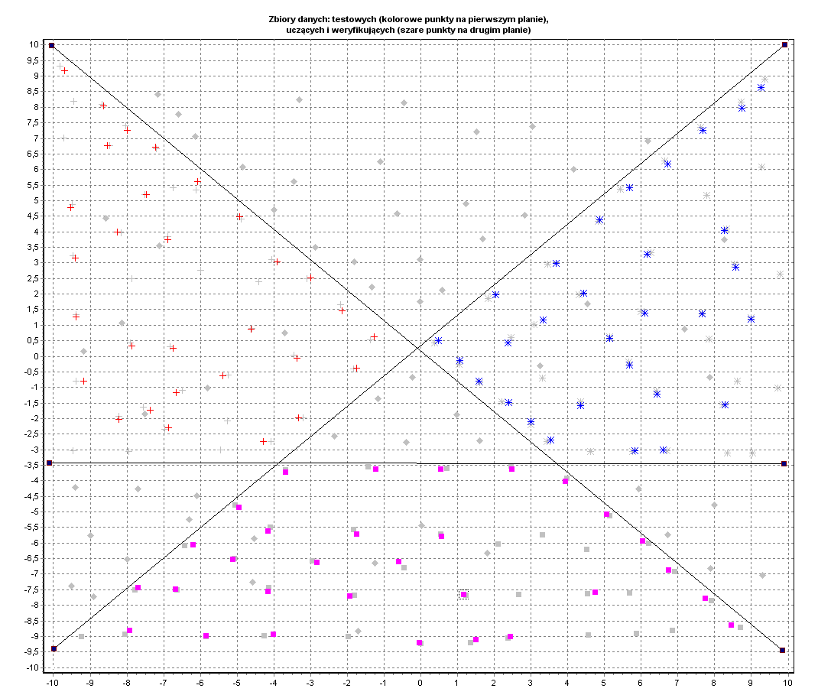
1 | -9,697 | 9,175 | Klasa 1
2 | -8,636 | 8,045 | Klasa 1
3 | -7,991 | 7,259 | Klasa 1
4 | -7,221 | 6,718 | Klasa 1
5 | -6,076 | 5,613 | Klasa 1
6 | -4,932 | 4,483 | Klasa 1
7 | -3,912 | 3,034 | Klasa 1
8 | -2,996 | 2,518 | Klasa 1
9 | -2,143 | 1,462 | Klasa 1
10 | -1,269 | 0,626 | Klasa 1
11 | -1,748 | -0,381 | Klasa 1
12 | -3,371 | -0,061 | Klasa 1
13 | -4,620 | 0,872 | Klasa 1
14 | -6,888 | 3,746 | Klasa 1
15 | -8,262 | 3,992 | Klasa 1
16 | -9,406 | 3,157 | Klasa 1
17 | -9,385 | 1,265 | Klasa 1
18 | -6,742 | 0,258 | Klasa 1
19 | -7,866 | 0,332 | Klasa 1
20 | -8,220 | -2,027 | Klasa 1
21 | -7,367 | -1,732 | Klasa 1
22 | -6,659 | -1,167 | Klasa 1
23 | -5,390 | -0,626 | Klasa 1
24 | -4,287 | -2,739 | Klasa 1
25 | -3,329 | -1,977 | Klasa 1
26 | -6,867 | -2,297 | Klasa 1
27 | -9,177 | -0,798 | Klasa 1
28 | -7,471 | 5,195 | Klasa 1
29 | -8,532 | 6,767 | Klasa 1
30 | -9,531 | 4,778 | Klasa 1
31 | 6,722 | 6,178 | Klasa 2
32 | 7,679 | 7,259 | Klasa 2
33 | 8,741 | 7,971 | Klasa 2
34 | 9,261 | 8,634 | Klasa 2
35 | 5,681 | 5,416 | Klasa 2
36 | 4,870 | 4,385 | Klasa 2
37 | 3,684 | 2,985 | Klasa 2
38 | 2,040 | 1,977 | Klasa 2
39 | 0,479 | 0,504 | Klasa 2
40 | 1,062 | -0,135 | Klasa 2
41 | 1,582 | -0,798 | Klasa 2
42 | 2,393 | -1,486 | Klasa 2
43 | 2,997 | -2,100 | Klasa 2
44 | 3,538 | -2,690 | Klasa 2
45 | 4,350 | -1,584 | Klasa 2
46 | 5,681 | -0,282 | Klasa 2
47 | 5,140 | 0,577 | Klasa 2
48 | 6,098 | 1,388 | Klasa 2
49 | 7,658 | 1,363 | Klasa 2
50 | 8,990 | 1,191 | Klasa 2
51 | 8,574 | 2,862 | Klasa 2
52 | 8,262 | 4,041 | Klasa 2
53 | 6,160 | 3,279 | Klasa 2
54 | 4,433 | 2,027 | Klasa 2
55 | 3,330 | 1,167 | Klasa 2
56 | 2,373 | 0,430 | Klasa 2
57 | 5,827 | -3,034 | Klasa 2
58 | 6,597 | -3,009 | Klasa 2
59 | 6,431 | -1,216 | Klasa 2
60 | 8,283 | -1,560 | Klasa 2
61 | -4,953 | -4,851 | Klasa 3
62 | -3,683 | -3,722 | Klasa 3
63 | -1,228 | -3,623 | Klasa 3
64 | 0,541 | -3,623 | Klasa 3
65 | 2,477 | -3,623 | Klasa 3
66 | 3,933 | -4,016 | Klasa 3
67 | 5,057 | -5,073 | Klasa 3
68 | 6,035 | -5,932 | Klasa 3
69 | 6,743 | -6,866 | Klasa 3
70 | 7,742 | -7,775 | Klasa 3
71 | 8,449 | -8,634 | Klasa 3
72 | 0,562 | -5,785 | Klasa 3
73 | -1,748 | -5,711 | Klasa 3
74 | -0,603 | -6,596 | Klasa 3
75 | -2,830 | -6,620 | Klasa 3
76 | -4,162 | -5,613 | Klasa 3
77 | -5,119 | -6,522 | Klasa 3
78 | -4,162 | -7,554 | Klasa 3
79 | -6,680 | -7,480 | Klasa 3
80 | -7,700 | -7,431 | Klasa 3
81 | -0,041 | -9,199 | Klasa 3
82 | 1,499 | -9,101 | Klasa 3
83 | 2,435 | -9,003 | Klasa 3
84 | 4,745 | -7,578 | Klasa 3
85 | -7,929 | -8,806 | Klasa 3
86 | -5,848 | -8,978 | Klasa 3
87 | -4,016 | -8,929 | Klasa 3
88 | -1,935 | -7,701 | Klasa 3
89 | -6,201 | -6,055 | Klasa 3
90 | 1,166 | -7,652 | Klasa 3

DANE WERYFIKUJĄCE:

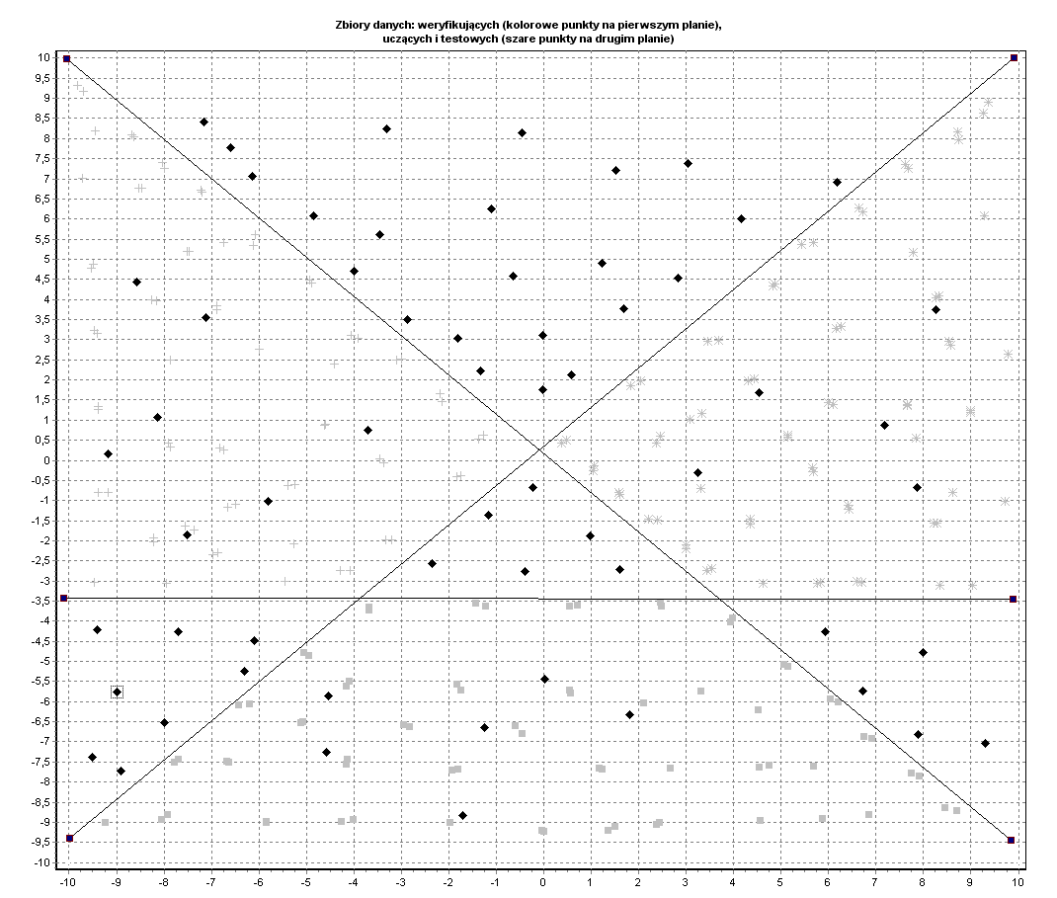
1 | -1,165 | -1,363
2 | -0,229 | -0,676
3 | 0,978 | -1,879
4 | -1,706 | -8,831
5 | -2,351 | -2,567
6 | -5,806 | -1,019
7 | -0,395 | -2,763
8 | 0,021 | -5,441
9 | -3,704 | 0,749
10 | 1,603 | -2,714
11 | -0,021 | 1,756
12 | -1,332 | 2,223
13 | -2,872 | 3,500
14 | -3,995 | 4,704
15 | -4,849 | 6,080
16 | -0,645 | 4,581
17 | 2,830 | 4,532
18 | 1,686 | 3,771
19 | -7,117 | 3,550
20 | -0,021 | 3,107
21 | 0,583 | 2,125
22 | 6,181 | 6,915
23 | 4,162 | 6,006
24 | 1,228 | 4,901
25 | -3,309 | 8,241
26 | -3,454 | 5,613
27 | -7,700 | -4,262
28 | -8,990 | -5,760
29 | -8,907 | -7,726
30 | -6,305 | -5,245
31 | -6,097 | -4,483
32 | -7,991 | -6,522
33 | -9,406 | -4,213
34 | -4,536 | -5,859
35 | -4,578 | -7,259
36 | 7,180 | 0,872
37 | 6,722 | -5,736
38 | 4,537 | 1,683
39 | 7,991 | -4,778
40 | 7,887 | -6,817
41 | 7,867 | -0,676
42 | 8,262 | 3,746
43 | 3,247 | -0,307
44 | 9,302 | -7,038
45 | 5,931 | -4,262
46 | -7,512 | -1,855
47 | -8,137 | 1,069
48 | -1,248 | -6,645
49 | 1,811 | -6,325
50 | -9,510 | -7,382
51 | -9,177 | 0,160
52 | -1,810 | 3,034
53 | -6,597 | 7,775
54 | -7,159 | 8,413
55 | -6,139 | 7,062
56 | -8,574 | 4,434
57 | -1,103 | 6,252
58 | -0,458 | 8,143
59 | 3,039 | 7,382
60 | 1,519 | 7,210

